**My RSP Sandbox Journal**

My Name:- Saloni Sanjay Gedam

This Is all about my journey started and ended in working with RSP Sandbox.

I have done a 2 projects are as follows:

1. Create a what’s app to do list.
2. Create a Simple Calculator.

Now in whats app todo list:

I was Languages like html css and javascript.. In that I had use some function in javascript. My snippeds of code.is like.

Html:-

I use this snipped for making list .

body>

    <div class="container">

        <header> My To Do List </header>

        <div class="inputField">

            <input type="text" placeholder="Add Your New To Do">

            <button><i class="fas fa-plus"></i></button>

        </div>

        <ul class="list">

            <!--  this is for css purpose i hade used <li>Buy a new gaming pc. <span><i class="fas fa-trash"></i></span></li>

            <li>Complete the previous task . <span><i class="fas fa-trash"></i></span></li>

            <li>MaKE A VIDEO ON youtube <span><i class="fas fa-trash"></i></span></li> -->

            <!-- Data comes from local storages -->

        </ul>

        <footer>

            <span>You Have a <span class="pendingNumb"></span> Pending Task.</span>

            <button>Clear All.</button>

        </footer>

    </div>

Css:-

y {

    height: 100vh;

    width: 100%;

    background-image: url('https://static1.makeuseofimages.com/wordpress/wp-content/uploads/2017/02/Photoshop-Replace-Background-Featured.jpg');

    background-size: cover;

    background-repeat: no-repeat;

}

.container {

    margin: 120px auto;

    max-width: 400px;

    width: 100%;

    background: var(--purple);

    border-radius: 10px;

    padding: 25px;

}

.container header {

    font-size: 40px;

    font-weight: 600;

    font-family: 'Dancing Script', cursive;

    color: white;

}

.container .inputField {

    display: flex;

    height: 45px;

    width: 100%;

    margin: 20px 0;

}

.inputField input {

    outline: none;

    width: 85%;

    height: 100%;

    border: 1px solid var(--grey);

    font-size: 17px;

    border-radius: 5px;

    padding-left: 15px;

}

.inputField button {

    width: 60px;

    height: 100%;

    border: none;

    outline: none;

    background-color: #4d004d;

    color: #fff;

    font-size: 20px;

    cursor: pointer;

    border-radius: 5px;

    margin-left: 5px;

    opacity: 0.5;

javascript:-

not full code some part of code I m showing to u

onst addBtn = document.querySelector(".inputField button");

const todoList = document.querySelector(".list");

const deleteAllBtn = document.querySelector("footer button");

inputBox.onkeyup = () => {

    let userData = inputBox.value; //getting user entered value

    if (userData.trim() != 0) { //if user values aren't only spaces

        addBtn.classList.add("active"); //active the add button

    } else {

        addBtn.classList.remove("active"); //unactive the add button

    }

}

showTasks();

addBtn.onclick = () => {

    let userData = inputBox.value;

    let getLocalStorage = localStorage.getItem("New Todo");

    if (getLocalStorage == null) {

        listArr = [];

    } else {

        listArr = JSON.parse(getLocalStorage);

    }

    listArr.push(userData);

    localStorage.setItem("New Todo", JSON.stringify(listArr));

    showTasks();

}

//function to add task list inside ul

function showTasks() {

    let getLocalStorage = localStorage.getItem("New Todo");

    if (getLocalStorage == null) {

        listArr = [];

Output:-

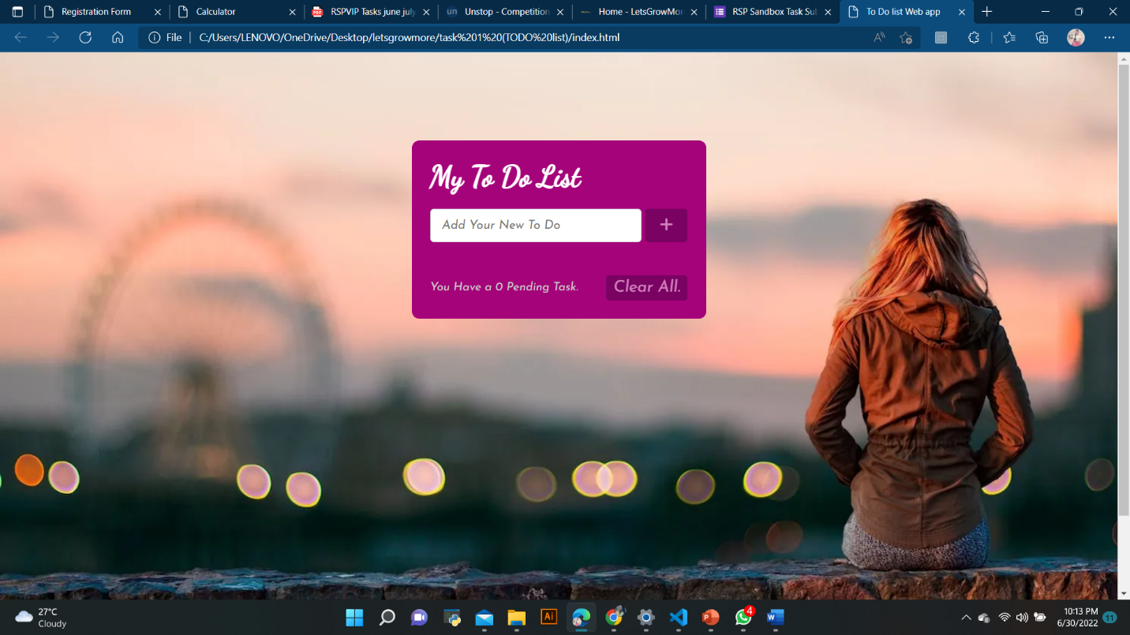

So in Calculator:-

I was Languages like html css and javascript.. In that I had use some function in javascript. My snippeds of code.is like.

Html:-

I use this snipped for showing no. and overall design all are input type. Which are used to take the input from user.

body>

    <div class="calculator">

        <div class="display">

            <input type="text" placeholder="0" id="input" disabled />

        </div>

        <div class="buttons">

            <!-- Full Erase -->

            <input type="button" value="AC" id="clear" />

            <!-- Erase Single Value -->

            <input type="button" value="DEL" id="erase" />

            <input type="button" value="/" class="input-button" />

            <input type="button" value="*" class="input-button" />

            <input type="button" value="7" class="input-button" />

            <input type="button" value="8" class="input-button" />

            <input type="button" value="9" class="input-button" />

            <input type="button" value="-" class="input-button" />

            <input type="button" value="6" class="input-button" />

            <input type="button" value="5" class="input-button" />

            <input type="button" value="4" class="input-button" />

            <input type="button" value="+" class="input-button" />

            <input type="button" value="1" class="input-button" />

            <input type="button" value="2" class="input-button" />

            <input type="button" value="3" class="input-button" />

            <input type="button" value="=" id="equal" />

            <input type="button" value="0" class="input-button" />

            <input type="button" value="." class="input-button" />

        </div>

    </div>

Css:-

This is some code. For giving look to my site.

tr:nth-child(even),

table.list thead>tr {

    background-color: #dddddd;

}

input[type=text],

input[type=number] {

    width: 100%;

    padding: 12px 20px;

    margin: 8px 0;

    display: inline-block;

    border: 1px solid #ccc;

    border-radius: 4px;

    box-sizing: border-box;

}

input[type=submit] {

    width: 30%;

    background-color: #ddd;

    color: #000;

    padding: 14px 20px;

    margin: 8px 0;

    border: none;

    border-radius: 4px;

    cursor: pointer;

Java script:

This is what calculator is working.

let equal_pressed = 0;

//Refer all buttons excluding AC and DEL

let button_input = document.querySelectorAll(".input-button");

//Refer input,equal,clear and erase

let input = document.getElementById("input");

let equal = document.getElementById("equal");

let clear = document.getElementById("clear");

let erase = document.getElementById("erase");

window.onload = () => {

    input.value = "";

};

//Access each class using forEach

button_input.forEach((button_class) => {

    button_class.addEventListener("click", () => {

        if (equal_pressed == 1) {

            input.value = "";

            equal_pressed = 0;

        }

        //display value of each button

        input.value += button_class.value;

    });

});

//Solve the user's input when clicked on equal sign

equal.addEventListener("click", () => {

    equal_pressed = 1;

    let inp_val = input.value;

    try {

        //evaluate user's input

        let solution = eval(inp_val);

        //True for natural numbers

        //false for decimals

        if (Number.isInteger(solution)) {

            input.value = solution;

        } else {

            input.value = solution.toFixed(2);

        }

    } catch (err) {

        //If user has entered invalid input

        alert("Invalid Input");

    }

});

//Clear Whole Input

clear.addEventListener("click", () => {

    input.value = "";

});

//Erase Single Digit

erase.addEventListener("click", () => {

    input.value = input.value.substr(0, input.value.length - 1);

});

Output:-

